24.7: Estimate 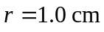
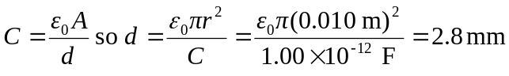
The separation between the pennies is nearly a factor of 10 smaller than the diameter of a penny, so it is a reasonable approximation to treat them as infinite sheets.

